PRESS: FOR IMMEDIATE RELEASE to all ARTS & CALENDAR EDITORS
April 22, 2015

WHAT: Olga de Amaral: El Oro Es Color
July 2 – August 29, 2015
No opening reception

WHERE: Bellas Artes Gallery
653 Canyon Road, Santa Fe

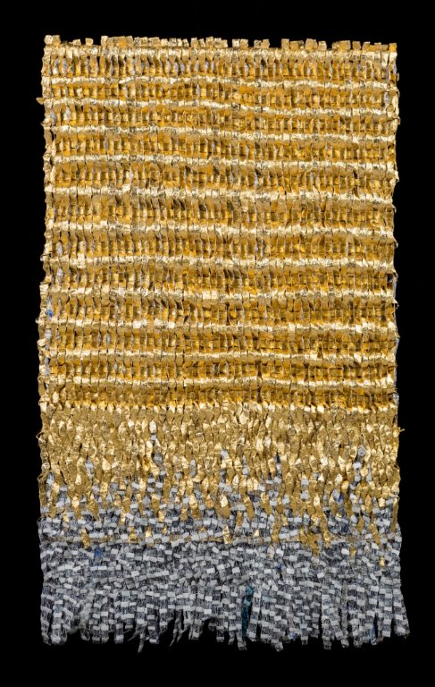
Olga de Amaral, Viento I, linen, gesso, acrylic and gold leaf, 58” x 36”, 2014
Bob and Charlotte Kornstein met the artist Olga de Amaral in Bogotá in 1971. One decade later, the Kornsteins had established their gallery, Bellas Artes in Santa Fe, where they have exhibited works by de Amaral since 1986. This summer, in anticipation of 30 years of a shared history, the Kornsteins are pleased to present El Oro Es Color, an exhibition of recent works including a new series by the artist. Renowned for her gold-leaf, fiber-based wall works, and represented in more than 25 important museum collections worldwide, de Amaral’s works push the boundaries of textiles to their very limits.

About her process, the artist states, “I like painting the thread instead of dyeing it because it is a much more controlled and intimate process,” likening her work to “painting in space.”
De Amaral’s artworks hang on the walls with the weight and presence of ancient, pre-Columbian stele, masks, and breastplates, equally evocative of the richness of medieval tapestries and chain mail. Despite their visual references to the artist’s native culture, they are in fact modern abstractions that focus upon color, tactility, and a process-driven physicality. They are ephemeral and timeless, and therein lies their satisfying tension: De Amaral’s work stands in for the past and the future within the context of the now. Nonetheless, the viewer may find himself approaching one of de Amaral’s artworks as if it were a priceless antiquity that murmurs in the gravely beautiful language of the sacred.
De Amaral was honored in 2011 at the Metropolitan Museum of Art’s Multicultural Gala: An Evening of Many Cultures. Text from the event program declares how remarkable her “woven walls” are
for their technical finesse and their deeply felt essence of Colombia, her native country … where she studied Architectural Design before traveling to the U.S. to attend the Textile and Design Program at Cranbrook Academy of Art in Michigan…. Color and structure are de Amaral’s most important formal concerns…, reminiscent of the [natural and vernacular landscapes] of her country.

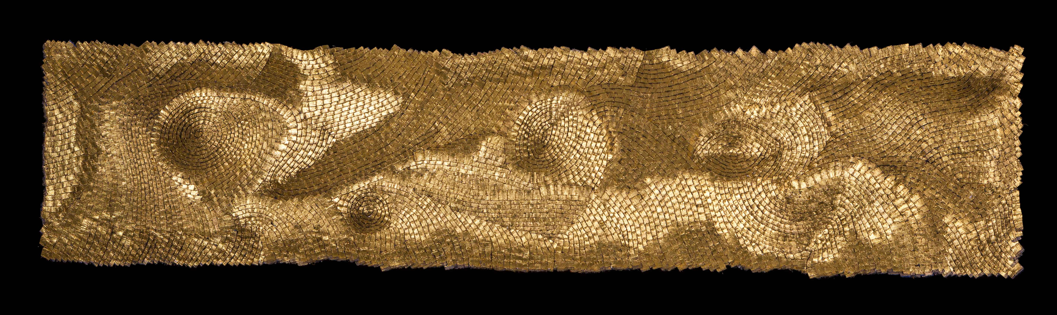
Olga de Amaral, Umbra 60, linen, gesso, acrylic and gold leaf, 17” x 78” 2014

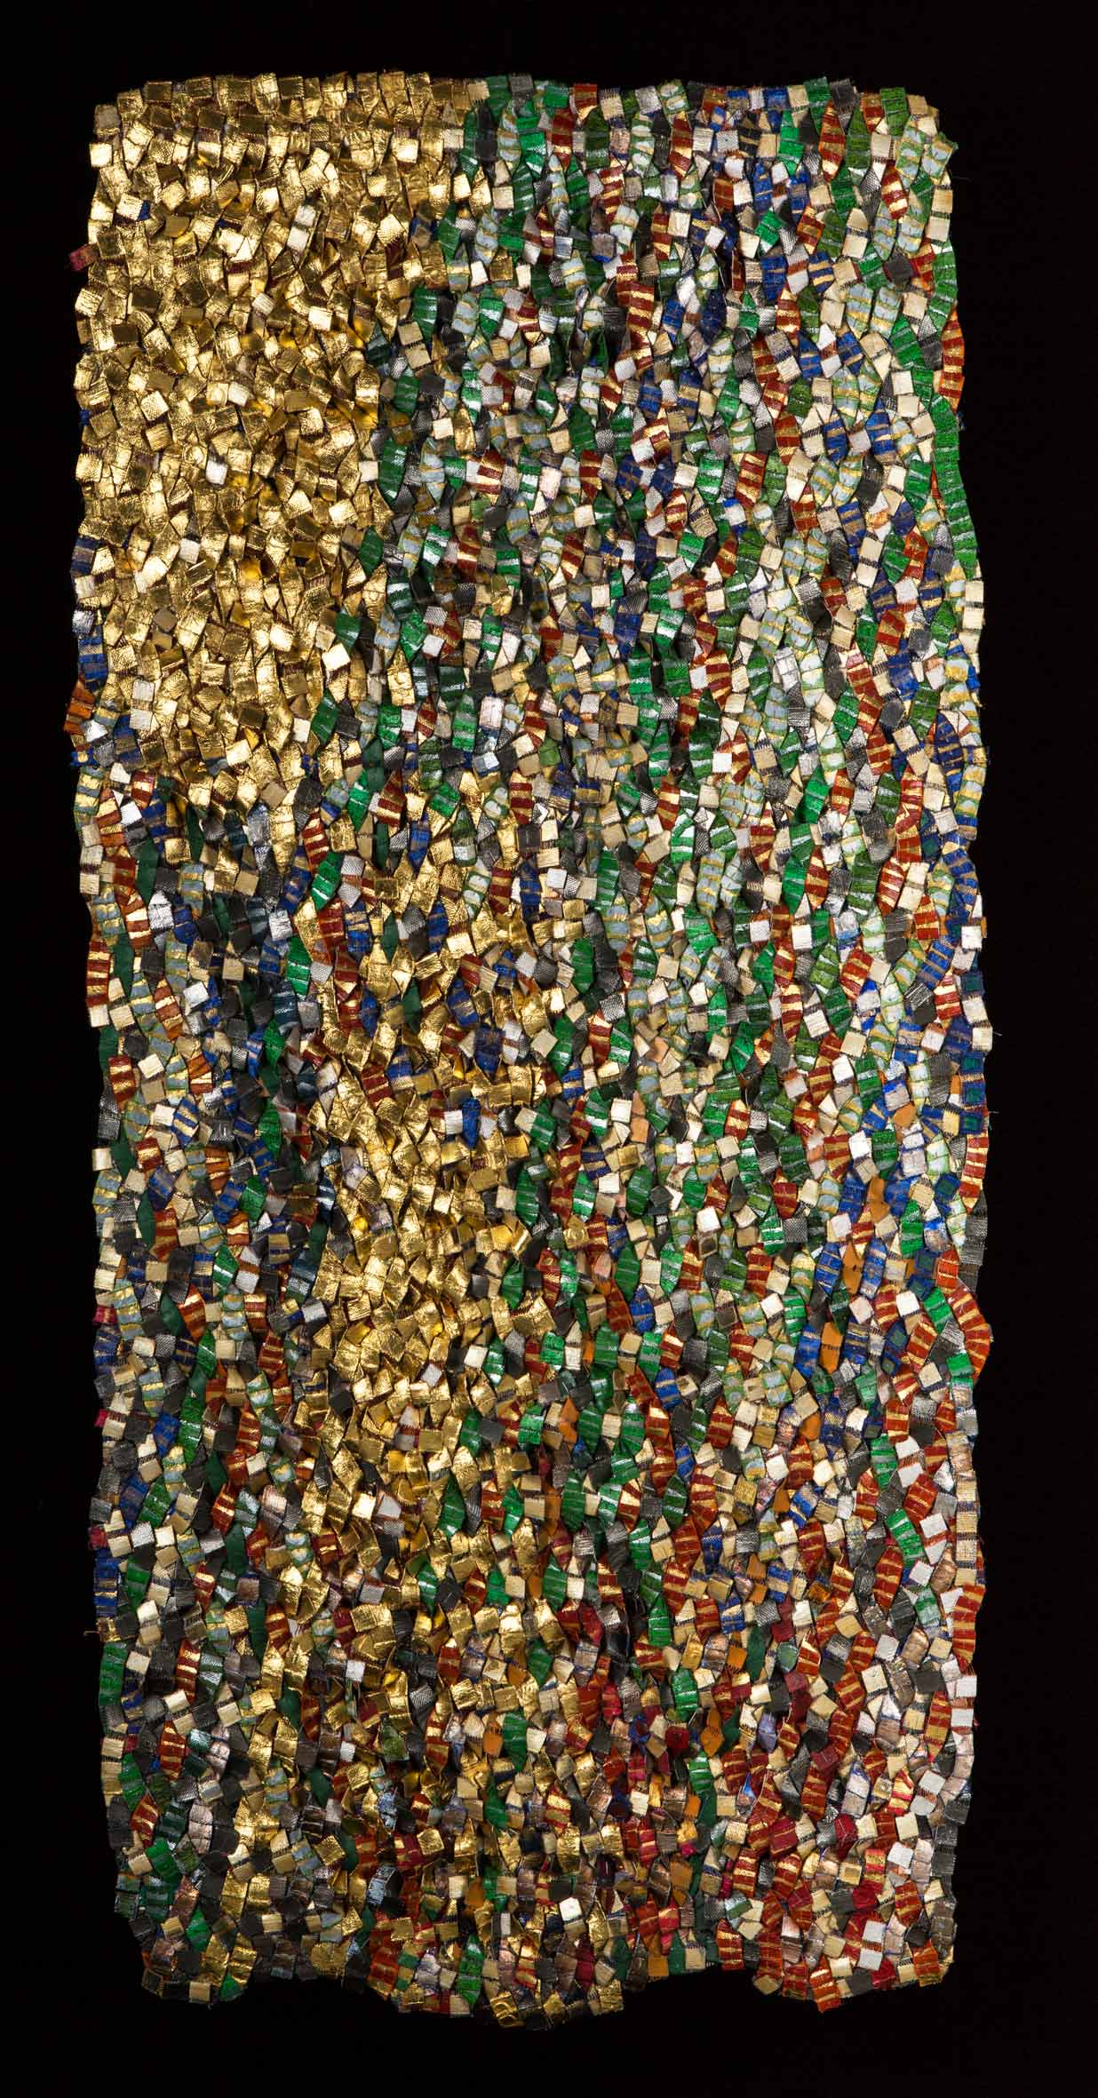
Olga de Amaral, Ombrio 17, linen, gesso, acrylic and gold leaf, 66” x 32”, 2014
A Guggenheim Fellowship recipient early in her career, de Amaral is a member of the Academía Nácional de Bellas Artes of Buenos Aires, Argentina. Her work is in the permanent collections of the Art Institute of Chicago; San Francisco’s De Young Museum; the Metropolitan Museum of Art and the Museum of Modern Art in New York; and the Renwick Gallery of the National Gallery in Washington, DC; as well as in museums in Paris, Zurich, Kyoto, and many others including, of course, her hometown, Bogotá, Colombia.

Contact: Charlotte Kornstein
505.983.2745
bc@bellasartesgallery.com
Bellas Artes Ltd. www.bellasartesgallery.com
653 Canyon Road, Santa Fe, NM 87501 505/983.2745

Hi-res images available upon request.

###

